VENICE HONGWANJI BUDDHIST TEMPLE
SANGHA SERIES- DEALING WITH RACISM AND HATE:
A JODO SHINSHU APPROACH
FEATURING REV. MATT HAMASAKI
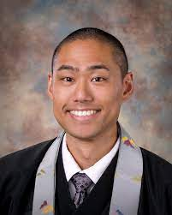
MONDAY, APRIL 26th 7:00 PM

- We are seeing increased racism and hate, some of it directed towards Asians and Asian-Americans- how do Jodo Shinshu Teachings guide us?
- What actions can we take to increase awareness of these issues while continuing to promote diversity and inclusiveness?
- What is the best approach for our Communities, Temples, and members & friends in dealing with this issue?

Rev. Matt Hamasaki, resident minister at the Sacramento Betsuin and a dynamic speaker, will share his thoughts and lead a Q&A session.
You may reserve your space in this free seminar at www.givebutter.com/vhbtsanghaseries.
Contact us at vhbtlive@gmail.com for more information.
This event was made possible through a grant from the Southern District Buddhist Women’s Association.

